***CONFIGURE Eclipse with Cucumber***

*To configure* ***Eclipse*** *with* ***Cucumber****, we need to launch the* ***Eclipse IDE****, create a* ***Workspace****, create a* ***Project*** *and* ***add External libraries*** *to the project.*

***Step******1****: Select WorkSpace on Eclipse start up*

1. *Double click on ‘****eclipse.exe****‘ to start eclipse.*

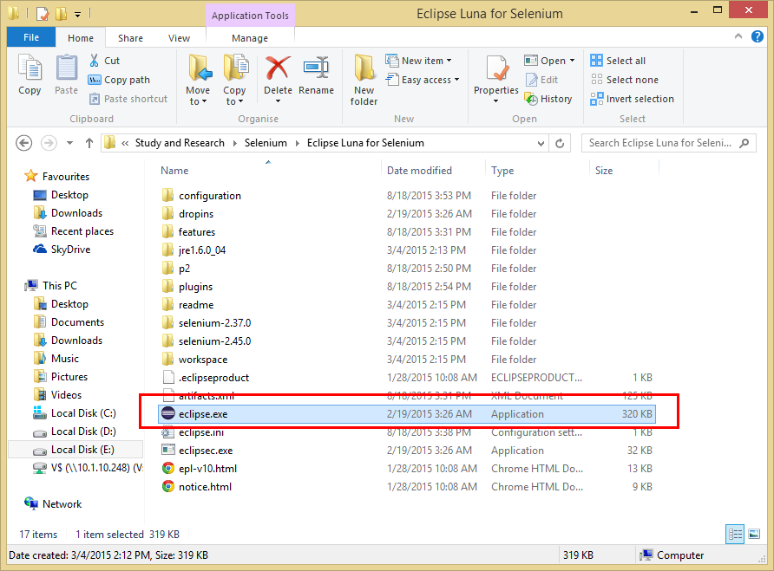

1. *Create a “****working directory****” for all of your projects.*

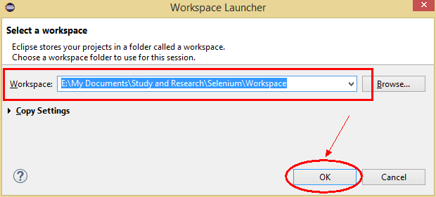

***Step 2:*** *Create a New Project*

1. *Create new Java Project from* ***File > New > Java Project.***

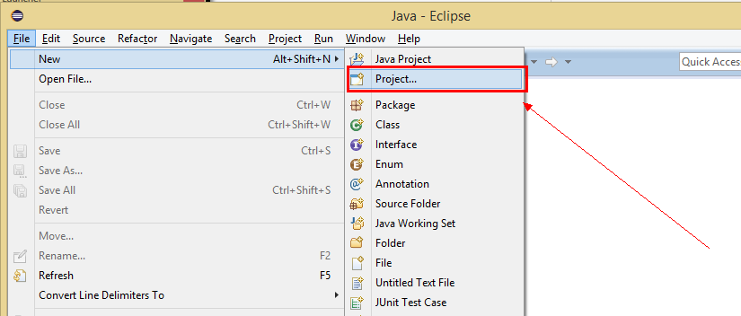

***Note****: You may see a direct option for Java Project, if you are using the latest version of Eclipse like LUNA.*

1. *Select* ***Java Project*** *and click* ***Next.***

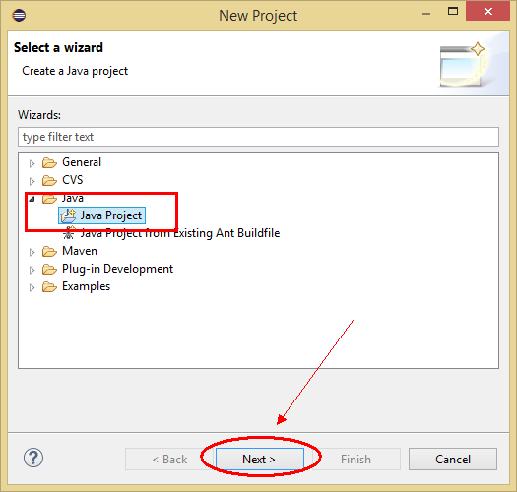

1. *Give your Project name ‘****OnlineStore****‘ as shown in below given figures. Click on* ***Finish*** *button*

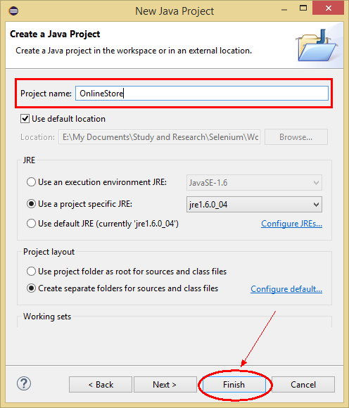

***Step 3****: Add External Jars to Java build path*

***Add Selenium Jars***

1. *Let’s first add Selenium Jars. Right click on Project ‘****OnlineStore’*** *>* ***Select******Properties*** *>* ***Java******build******path****. Then navigate to* ***Libraries*** *tab and click* ***Add******External******JARs****.*

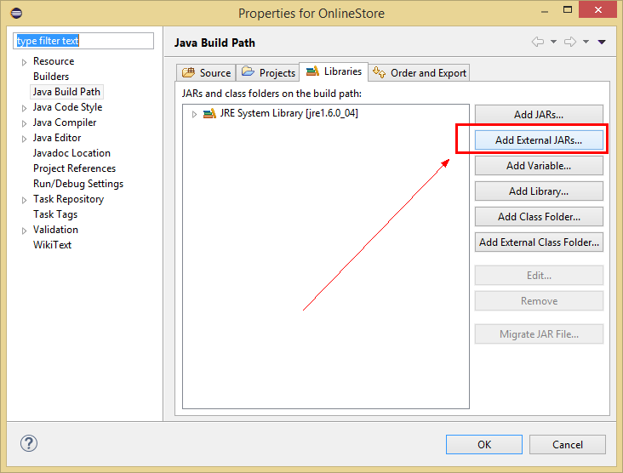

1. *Add* ***Selenium Java*** *jar, you may add the source file too.*

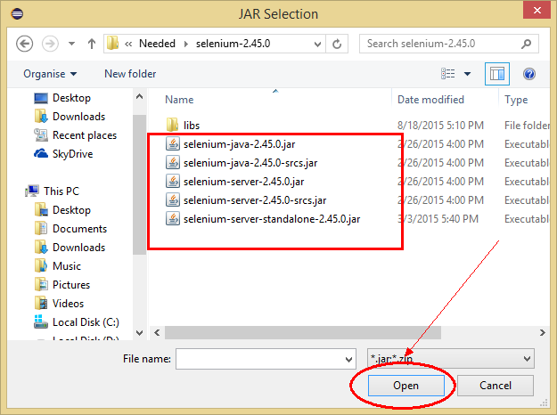

1. *Add all the* ***Jars*** *from the* ***libs*** *folder as well.*

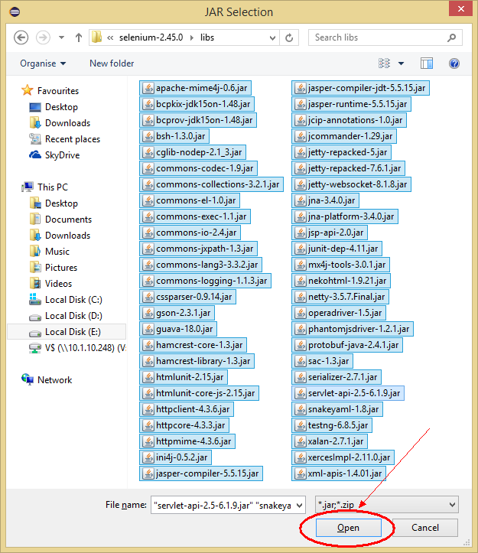

1. *Click* ***OK.***

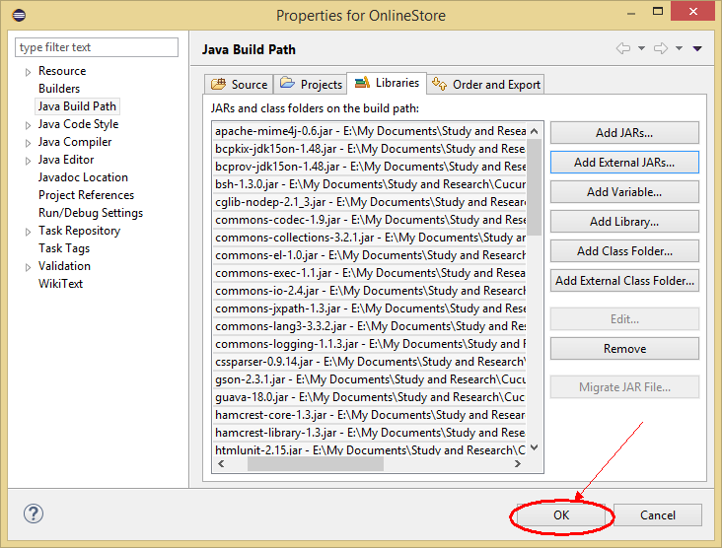

***Add Cucumber Jars***

1. *Right click on Project ‘****OnlineStore’*** *>* ***Select******Properties*** *>* ***Java******build******path****. Then navigate to* ***Libraries*** *tab and click* ***Add******External******JARs****.*

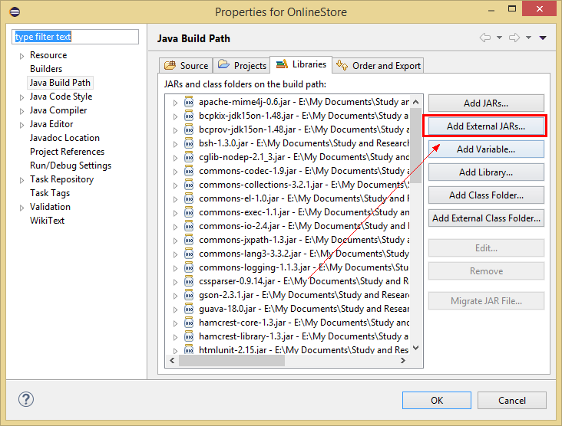

1. *Add all the* ***Cucumber’s Jars*** *to the project and click* ***Open****.*

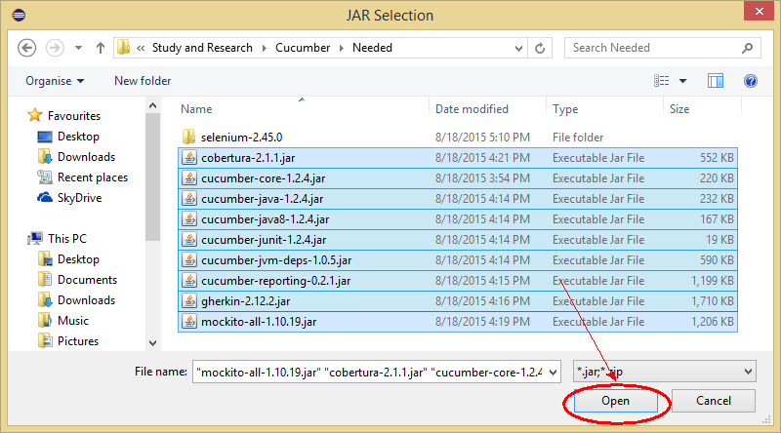

1. *Click* ***OK***

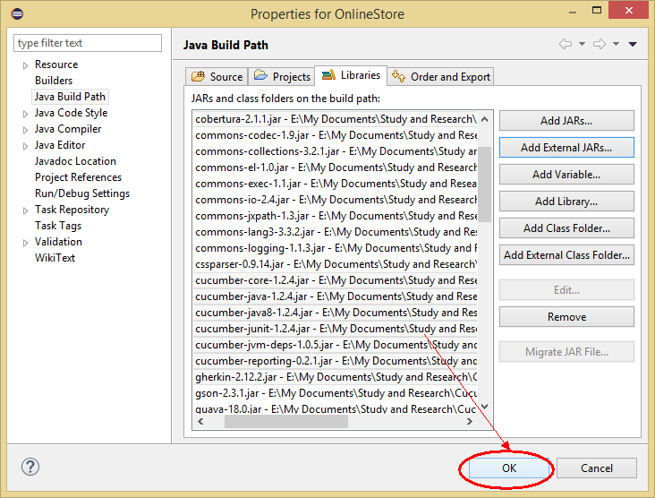

1. *This is how the project looks like in Eclipse.*

